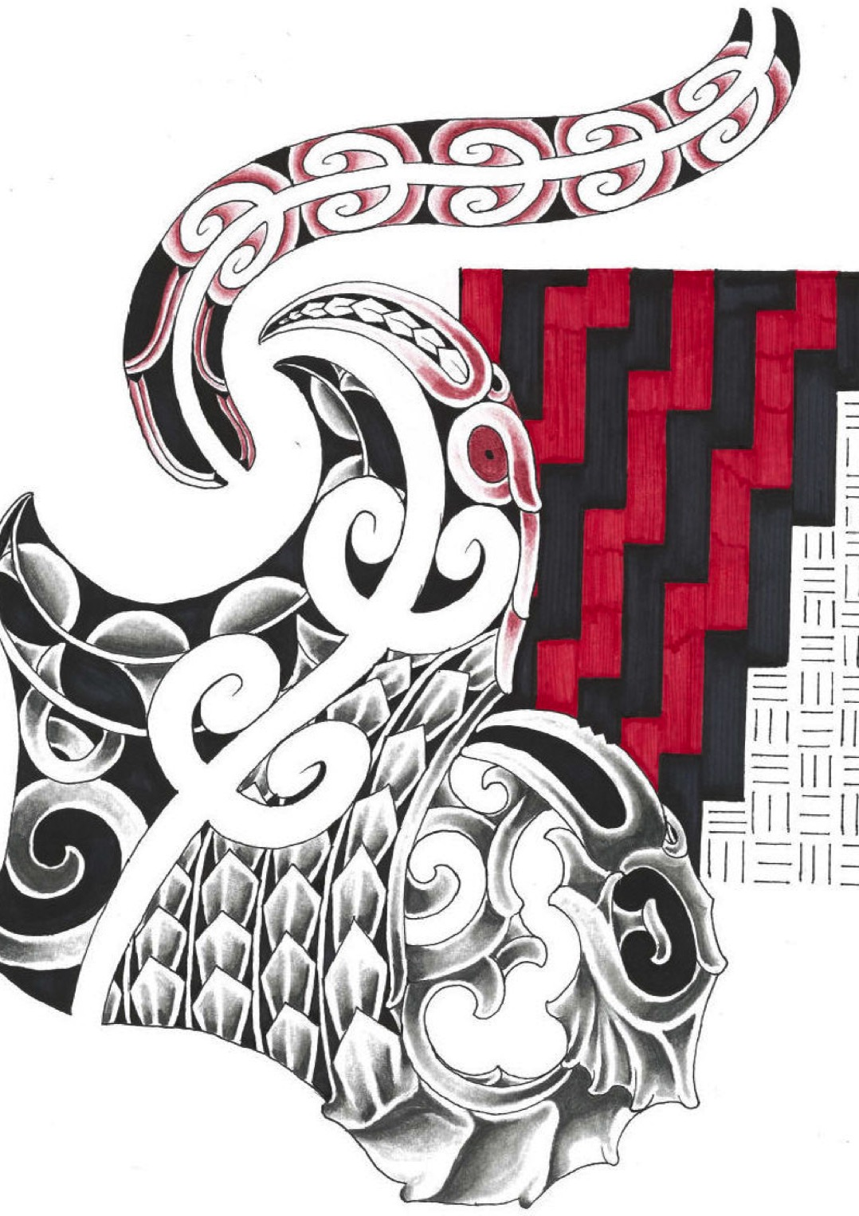

TE MANAWA ORA
ORDER FORM

Please note that only TMO exponents will be able to wear Kaakahu

Men’s Razor V-Neck Top $50 | S | M | L | XL | 2XL | 3XL | 5XL
T406MS
Men’s Geneva Jacket $85 | S | M | L | XL | 2XL | 3XL | 5XL
J307M
Men’s Geneva Vest $80 | S | M | L | XL | 2XL | 3XL | 5XL
J404M
Men’s Quay Shirt $65 | S | M | L | XL | 2XL | 3XL | 5XL
S231ML

Ladies Razor Polo $50 | 8 | 10 | 12 | 14 | 16 | 18 | 20 | 22 | 24
P405LS
Ladies Geneva Jacket $85 | S | M | L | XL | 2XL | *** | *** | *** | ***
J307L
Ladies Geneva Vest $80 | S | M | L | XL | 2XL | *** | *** | *** | ***
J404L
Ladies Quay Shirt $65 | 8 | 10 | 12 | 14 | 16 | 18 | 20 | 22 | 24
S231LT

Razor Kids Polo $50 | 4 | 6 | 8 | 10 | 12 | 14 | 16
P405KS

Sports Bag $55  BB411 | Back Pack $55  BB410

Name _________________________________________________________________

Contact Number______________________________________________________

Total Cost___________________________ Total Items__________________

