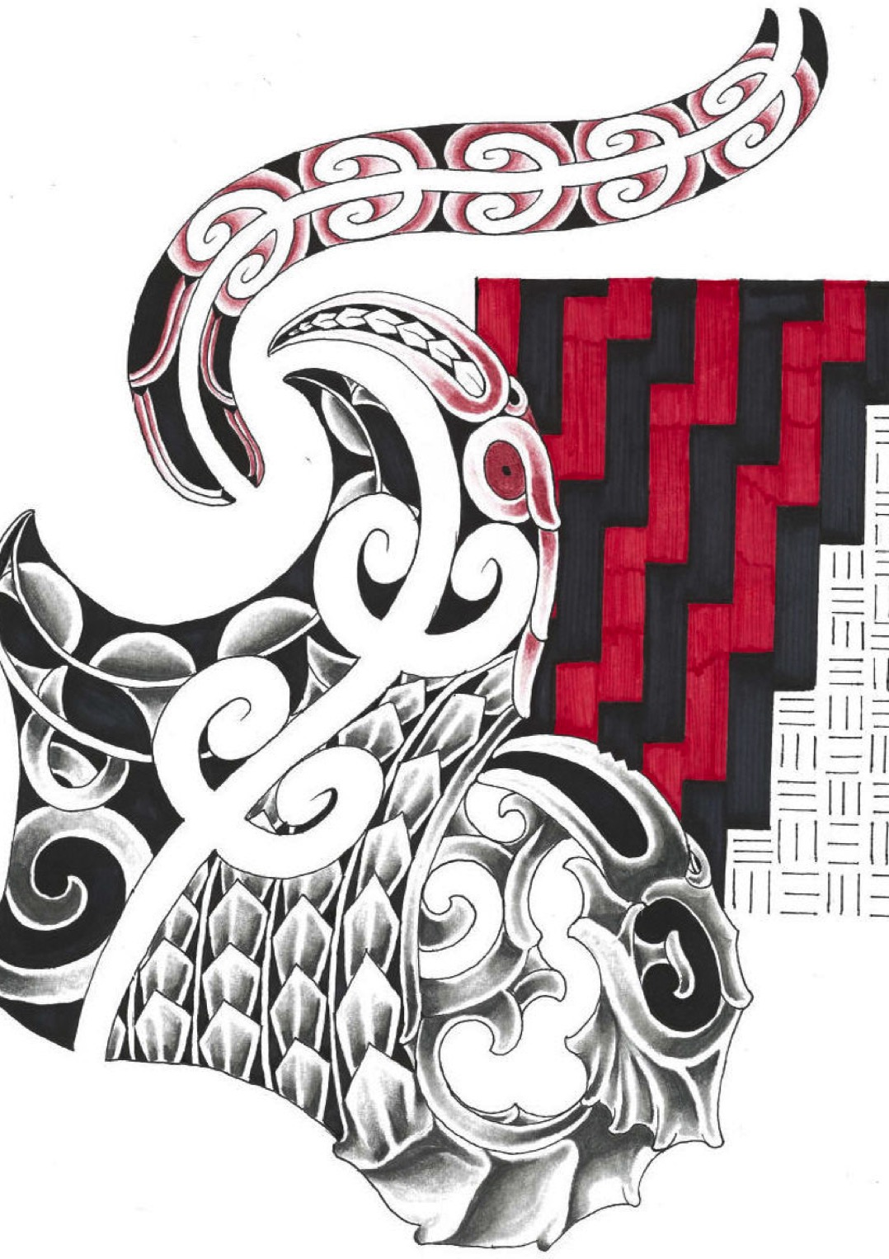

TE MANAWA ORA
ORDER FORM

Please note that only TMO exponents will be able to wear Kaakahu

Men’s Razor V-Neck Top $50 | S | M | L | XL | 2XL | 3XL | 5XL
Men’s Geneva Jacket $80 | S | M | L | XL | 2XL | 3XL | 5XL
Men’s Geneva Vest $80 | S | M | L | XL | 2XL | 3XL | 5XL
Men’s Quay Shirt $55 | S | M | L | XL | 2XL | 3XL | 5XL

Ladies Razor Polo $50 | 8 | 10 | 12 | 14 | 16 | 18 | 20 | 22 | 24
Ladies Geneva Jacket $80 | S | M | L | XL | 2XL | *** | *** | *** | ***
Ladies Geneva Vest $80 | S | M | L | XL | 2XL | *** | *** | *** | ***
Ladies Quay Shirt $55 | 8 | 10 | 12 | 14 | 16 | 18 | 20 | 22 | 24

Razor Kids Polo $50 | 4 | 6 | 8 | 10 | 12 | 14 | 16

Sports Bag $50 | Back Pack $50

Name _________________________________________________________________

Contact Number______________________________________________________

Total Cost___________________________ Total Quantity__________________

