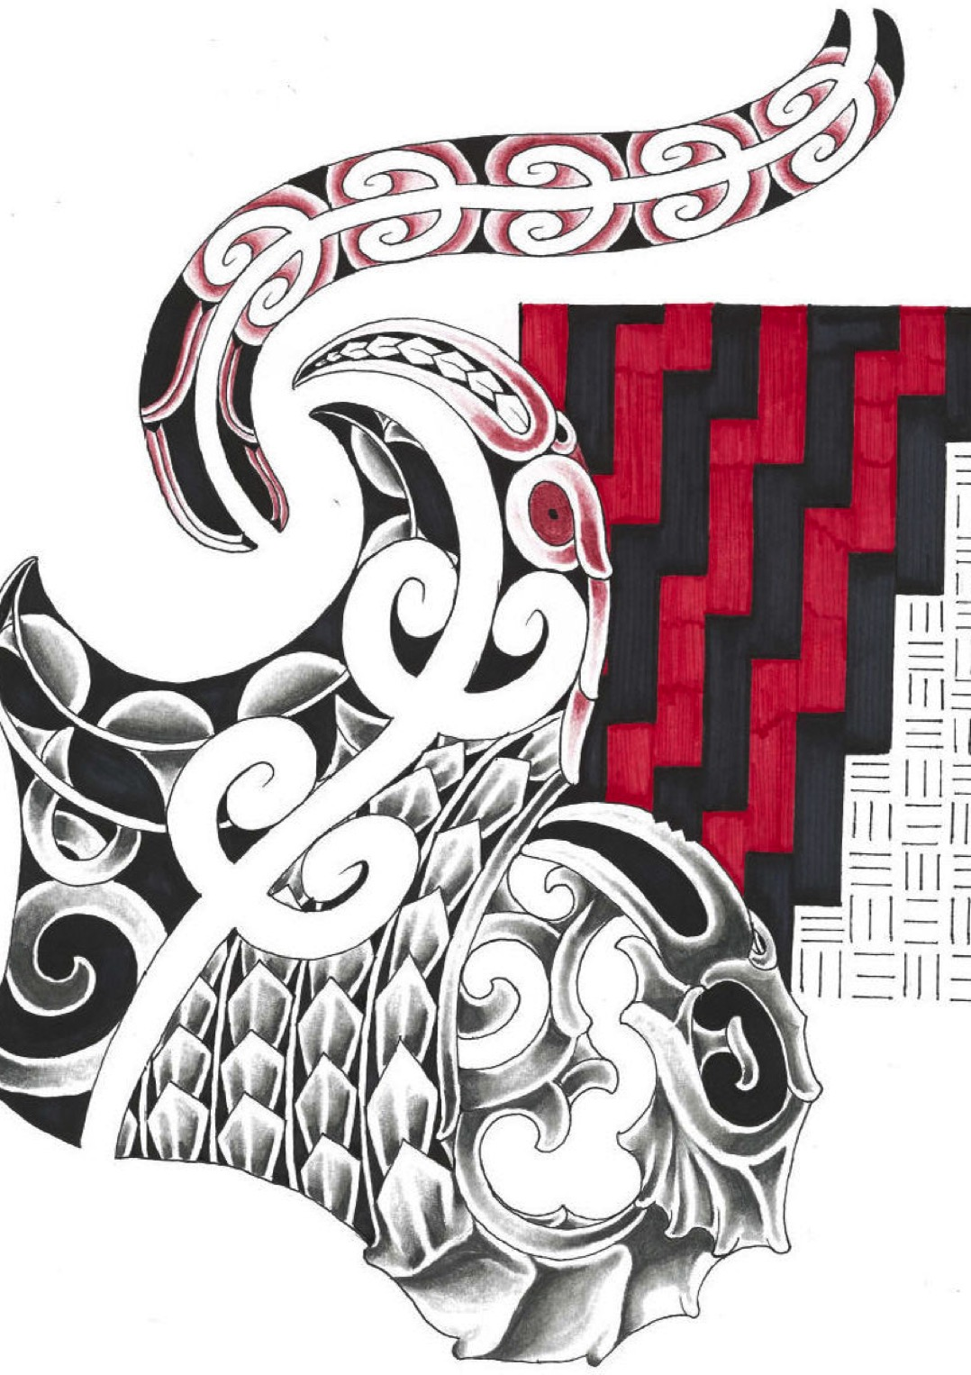

TE MANAWA ORA
KAAKAHU
ORDER FORM

Please note that only Te Manawa Ora Whanau will be able to wear Kaakahu

Prices are per Kaakahu, Men V-neck Shirts $50
Women Polo Shirts $50, Kids Polo Shirts $50

 | S | M | L | XL | 2XL | 3XL | 5XL
Men

 | 8 | 10 | 12 | 14 | 16 | 18 | 20 | 22 | 24
Women

 | 4 | 6 | 8 | 10 | 12 | 14 | 16
Kids

Name__________________________________________________________Number___________________

Total Quantity of Kaakahu__________________________ Total Cost________________________

